**Student’s Project**

**MOROCCO**

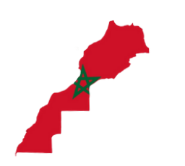

**The Moroccan Education System Between Theory and Practice**

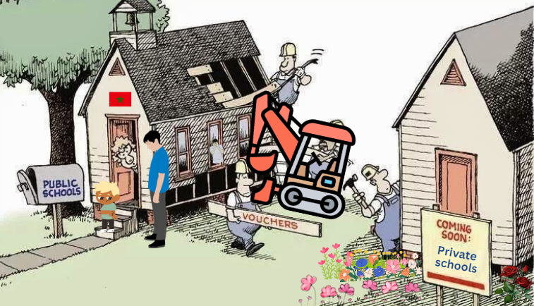

**The researcher : Malak Ben Saghir**

Supervised by : Prof. Mohamed Fettah

School: Moulay Ismail High School

**Outline**

1. **Part One (Theory) ...........................................................**
2. **Introduction.**
   1. An overview of the Moroccan education system.
   2. Major reforms and their intended goals.
3. **Problems and Challenges.**
4. In infrastructure and resources.
5. In teachers’ training and their performance in the classroom.
6. In the textbooks’ content.
7. In the influence of Morocco’s socioeconomic and cultural diversity on education.
8. **Bridging the gap between theory and practice.**
   1. In translating policies into actionable strategies.
   2. In integrating innovative practices
   3. In involving parents, local communities, and private sector.
   4. In promoting accountability and shared responsibility.
9. **Comparative Insights**
   1. Comparative analysis with other countries.
   2. Adaptable strategies for Morocco.
10. **Part Two (Practice) ........................................................**

* **Share informative posters about my research.**
* **Make a video for sharing my own vision on education.**

**Abstract**



**The Moroccan education system has seen significant reforms which aim at not only developing its structure but also improving its outcomes. This research provides an overview of the Moroccan education system as well as highlights major policy changes and their intended goals, such as enhancing access to education and aligning curricula with global standards. As a matter of fact, despite these efforts, the gap between the theoretical frameworks of these reforms and their practical implementation throughout the years continues to hinder the achievement of a real progress in the Moroccan school.**

**Key issues affecting the Moroccan education system include inadequate infrastructure and insufficient resources, particularly in rural areas. Also teacher training programs often fail to equip educators with the skills needed to develop their performance in the classroom. Furthermore, having outdated and culturally insensitive textbooks are additional barriers to effective learning. These challenges underscore the need to address systemic disparities and create a more inclusive and equitable education system.**

**Apart from this, this research provides a comparative analysis with other countries facing similar educational challenges. It provides valuable insights for developing the Moroccan education system. Because drawing conclusions from these experiences, the research outlines actionable steps that can guide policymakers in creating an effective education system.**

**In conclusion, this research emphasizes the urgent need for addressing the tensions and contradictions between reforms in education and their implementation in reality.**

"Knowledge bears fruit only when it is joined with action; otherwise, it is but barren theory."

Ibn Khaldoun